Select the right data
Following are some data-collection considerations to keep in mind for your analysis:

How the data will be collected
Decide if you will collect the data using your own resources or receive (and possibly purchase it) from another party. Data that you collect yourself is called first-party data.

Data sources
If you don’t collect the data using your own resources, you might get data from second-party or third-party data providers. Second-party data is collected directly by another group and then sold. Third-party data is sold by a provider that didn’t collect the data themselves. Third-party data might come from a number of different sources.

Solving your business problem
Datasets can show a lot of interesting information. But be sure to choose data that can actually help solve your problem question. For example, if you are analyzing trends over time, make sure you use time series data — in other words, data that includes dates.

How much data to collect
If you are collecting your own data, make reasonable decisions about sample size. A random sample from existing data might be fine for some projects. Other projects might need more strategic data collection to focus on certain criteria. Each project has its own needs.

Time frame
If you are collecting your own data, decide how long you will need to collect it, especially if you are tracking trends over a long period of time. If you need an immediate answer, you might not have time to collect new data. In this case, you would need to use historical data that already exists.
Use the flowchart below if data collection relies heavily on how much time you have
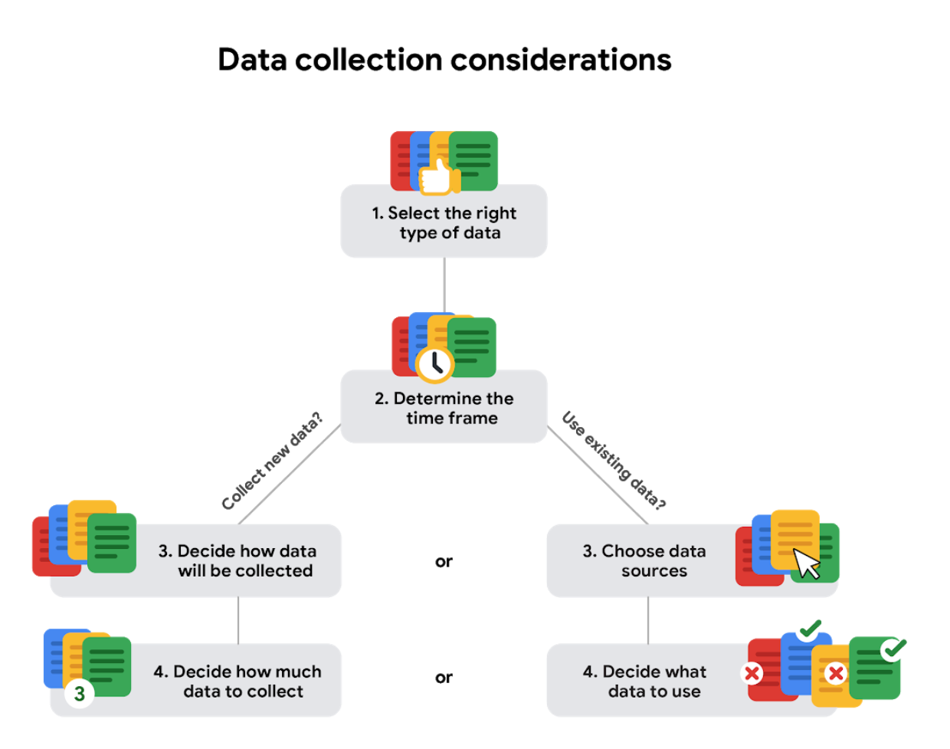

Data formats in practice
When you think about the word "format," a lot of things might come to mind. Think of an advertisement for your favorite store. You might find it in the form of a print ad, a billboard, or even a commercial. The information is presented in the format that works best for you to take it in. The format of a dataset is a lot like that, and choosing the right format will help you manage and use your data in the best way possible.

Data format examples
As with most things, it is easier for definitions to click when you can pair them with examples you might encounter on a daily basis. Review each data format’s definition first and then use the examples to lock in your understanding.

Primary versus secondary data
The following table highlights the differences between primary and secondary data and presents examples of each.
Data format classification | Definition | Examples
Primary data | Collected by a researcher from first-hand sources | - Data from an interview you conducted - Data from a survey returned from 20 participants  - Data from questionnaires you got back from a group of workers
Secondary data | Gathered by other people or from other research | - Data you bought from a local data analytics firm’s customer profiles  - Demographic data collected by a university  - Census data gathered by the federal government

Internal versus external data
The following table highlights the differences between internal and external data and presents examples of each.
Data format classification | Definition | Examples
Internal data | Data that is stored inside a company’s own systems | - Wages of employees across different business units tracked by HR  - Sales data by store location  - Product inventory levels across distribution centers
External data | Data that is stored outside of a company or organization | - National average wages for the various positions throughout your organization  - Credit reports for customers of an auto dealership

Continuous versus discrete data
The following table highlights the differences between continuous and discrete data and presents examples of each.
Data format classification | Definition | Examples
Continuous data | Data that is measured and can have almost any numeric value | - Height of kids in third grade classes (52.5 inches, 65.7 inches)  - Runtime markers in a video  - Temperature
Discrete data | Data that is counted and has a limited number of values | - Number of people who visit a hospital on a daily basis (10, 20, 200)  - Maximum capacity allowed in a room  - Tickets sold in the current month

Qualitative versus quantitative data
The following table highlights the differences between qualitative and quantitative data and presents examples of each.
Data format classification | Definition | Examples
Qualitative | A subjective and explanatory measure of a quality or characteristic | - Favorite exercise activity  - Brand with best customer service  - Fashion preferences of young adults
Quantitative | A specific and objective measure, such as a number, quantity, or range | - Percentage of board certified doctors who are women  - Population size of elephants in Africa  - Distance from Earth to Mars at a particular time

Nominal versus ordinal data
The following table highlights the differences between nominal and ordinal data and presents examples of each.
Data format classification | Definition | Examples
Nominal | A type of qualitative data that is categorized without a set order | - First time customer, returning customer, regular customer  - New job applicant, existing applicant, internal applicant  - New listing, reduced price listing, foreclosure
Ordinal | A type of qualitative data with a set order or scale | - Movie ratings (number of stars: 1 star, 2 stars, 3 stars)  - Ranked-choice voting selections (1st, 2nd, 3rd)  - Satisfaction level measured in a survey (satisfied, neutral, dissatisfied)

Structured versus unstructured data
The following table highlights the differences between structured and unstructured data and presents examples of each.
Data format classification | Definition | Examples
Structured data | Data organized in a certain format, like rows and columns | - Expense reports  - Tax returns  - Store inventory
Unstructured data | Data that cannot be stored as columns and rows in a relational database. | - Social media posts  - Emails  - Videos

The effects of different structures
Data is everywhere and it can be stored in lots of ways. Two general categories of data are:
- Structured data: Organized in a certain format, such as rows and columns.
- Unstructured data: Not organized in any easy-to-identify way.
For example, when you rate your favorite restaurant online, you're creating structured data. But when you use Google Earth to check out a satellite image of a restaurant location, you're using unstructured data.
Here's a refresher on the characteristics of structured and unstructured data:
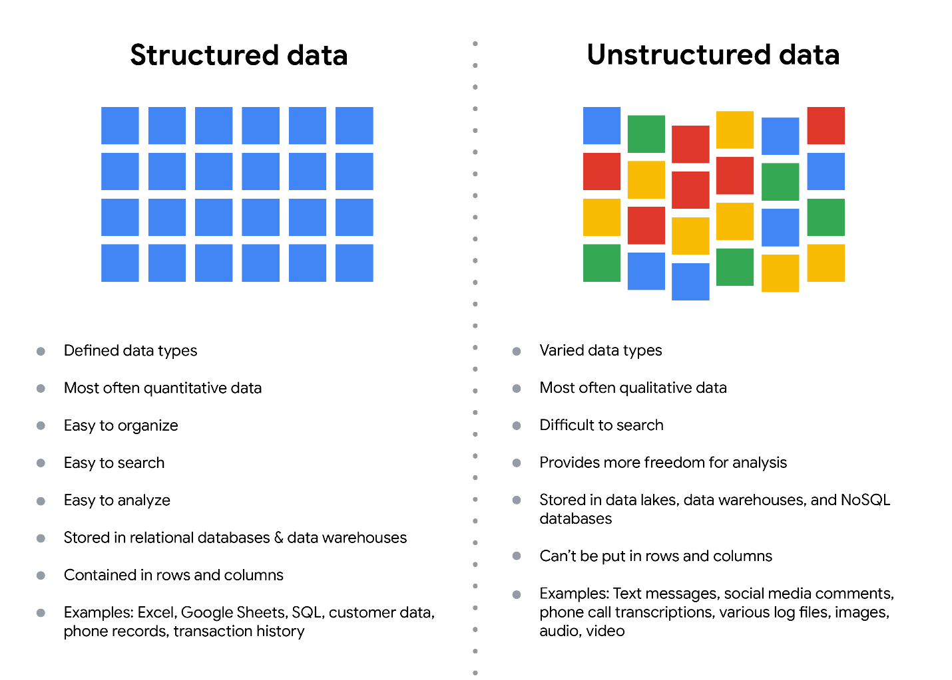

Structured data
As we described earlier, structured data is organized in a certain format. This makes it easier to store and query for business needs. If the data is exported, the structure goes along with the data.

Unstructured data
Unstructured data can’t be organized in any easily identifiable manner. And there is much more unstructured than structured data in the world. Video and audio files, text files, social media content, satellite imagery, presentations, PDF files, open-ended survey responses, and websites all qualify as types of unstructured data.

The fairness issue
The lack of structure makes unstructured data difficult to search, manage, and analyze. But recent advancements in artificial intelligence and machine learning algorithms are beginning to change that. Now, the new challenge facing data scientists is making sure these tools are inclusive and unbiased. Otherwise, certain elements of a dataset will be more heavily weighted and/or represented than others. And as you're learning, an unfair dataset does not accurately represent the population, causing skewed outcomes, low accuracy levels, and unreliable analysis.

Wide data is a dataset in which every data subject has a single row with multiple columns to hold the values of various attributes of the subject. It is helpful for comparing specific attributes across different subjects.
Long data is data in which each row represents one observation per subject, so each subject will be represented by multiple rows. This data format is useful for comparing changes over time or making other comparisons across subjects.
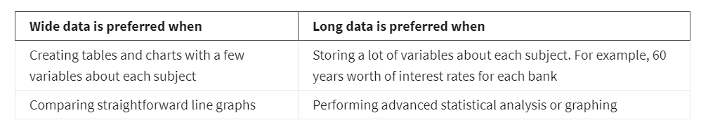

Data modeling is the process of creating diagrams that visually represent how data is organized and structured. These visual representations are called data models.

Levels of data modeling
Each level of data modeling has a different level of detail.
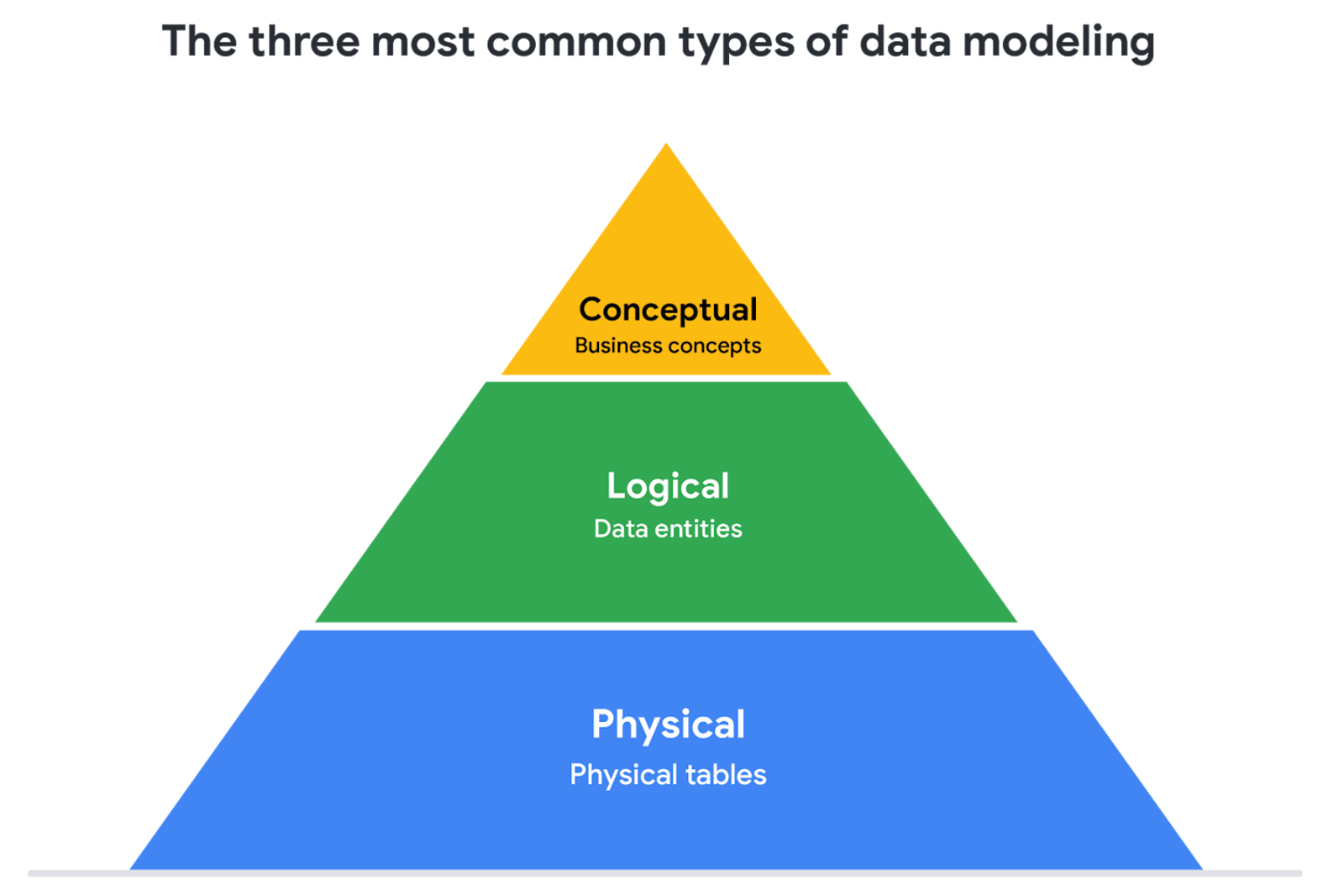
- Conceptual data modeling gives a high-level view of the data structure, such as how data interacts across an organization. For example, a conceptual data model may be used to define the business requirements for a new database. A conceptual data model doesn't contain technical details.
- Logical data modeling focuses on the technical details of a database such as relationships, attributes, and entities. For example, a logical data model defines how individual records are uniquely identified in a database. But it doesn't spell out actual names of database tables. That's the job of a physical data model.
- Physical data modeling depicts how a database operates. A physical data model defines all entities and attributes used; for example, it includes table names, column names, and data types for the database.

Glossary terms from module 1

Terms and definitions for Course 3, Module 1
Agenda: A list of scheduled appointments
Audio file: Digitized audio storage usually in an MP3, AAC, or other compressed format
Boolean data: A data type with only two possible values, usually true or false
Continuous data: Data that is measured and can have almost any numeric value
Cookie: A small file stored on a computer that contains information about its users
Data element: A piece of information in a dataset
Data model: A tool for organizing data elements and how they relate to one another
Digital photo: An electronic or computer-based image usually in BMP or JPG format
Discrete data: Data that is counted and has a limited number of values
External data: Data that lives, and is generated, outside of an organization
Field: A single piece of information from a row or column of a spreadsheet; in a data table, typically a column in the table
First-party data: Data collected by an individual or group using their own resources
Long data: A dataset in which each row is one time point per subject, so each subject has data in multiple rows
Nominal data: A type of qualitative data that is categorized without a set order
Ordinal data: Qualitative data with a set order or scale
Ownership: The aspect of data ethics that presumes individuals own the raw data they provide and have primary control over its usage, processing, and sharing
Pixel: In digital imaging, a small area of illumination on a display screen that, when combined with other adjacent areas, forms a digital image
Population: In data analytics, all possible data values in a dataset
Record: A collection of related data in a data table, usually synonymous with row
Sample: In data analytics, a segment of a population that is representative of the entire population
Second-party data: Data collected by a group directly from its audience and then sold
Social media: Websites and applications through which users create and share content or participate in social networking
String data type: A sequence of characters and punctuation that contains textual information (Refer to Text data type)
Structured data: Data organized in a certain format such as rows and columns
Text data type: A sequence of characters and punctuation that contains textual information (also called string data type)
United States Census Bureau: An agency in the U.S. Department of Commerce that serves as the nation’s leading provider of quality data about its people and economy
Unstructured data: Data that is not organized in any easily identifiable manner
Video file: A collection of images, audio files, and other data usually encoded in a compressed format such as MP4, MV4, MOV, AVI, or FLV
Wide data: A dataset in which every data subject has a single row with multiple columns to hold the values of various attributes of the subject

